**ASSIGNMENT OPERATORS:**

1.Write your own program using arithmetic operators?

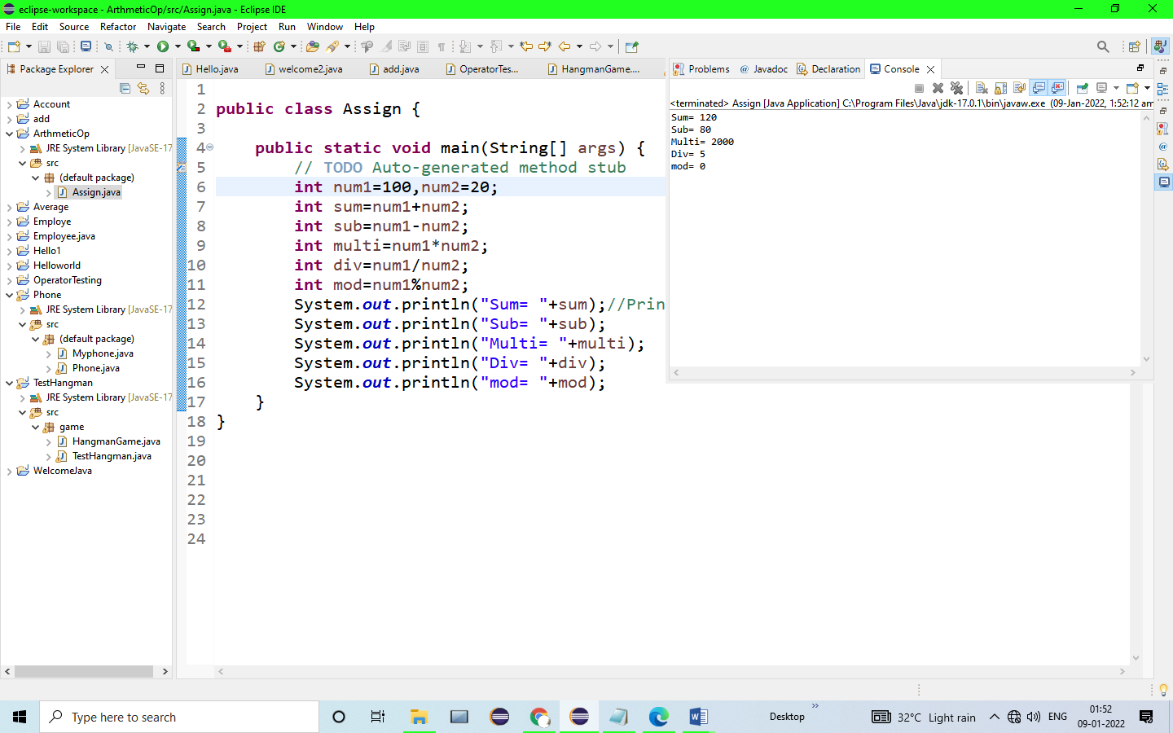

OUTPUT:

Sum= 120

Sub= 80

Multi= 2000

Div= 5

mod= 0

2.Write your own program using arithmetic assignment operators.

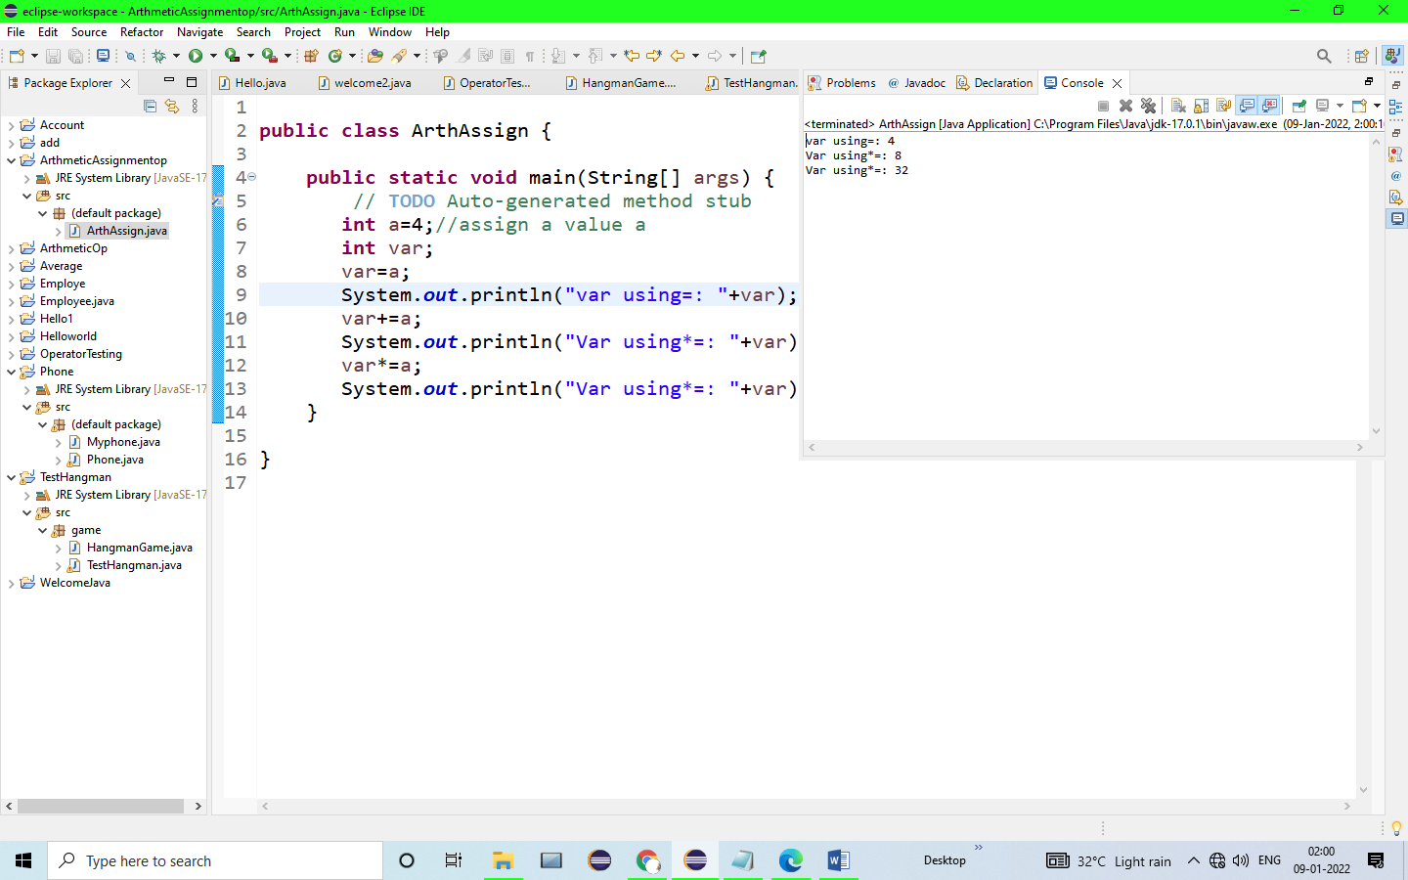

OUTPUT:

var using=: 4

Var using*=: 8

Var using*=: 32

4. Write your own program using relational operators.

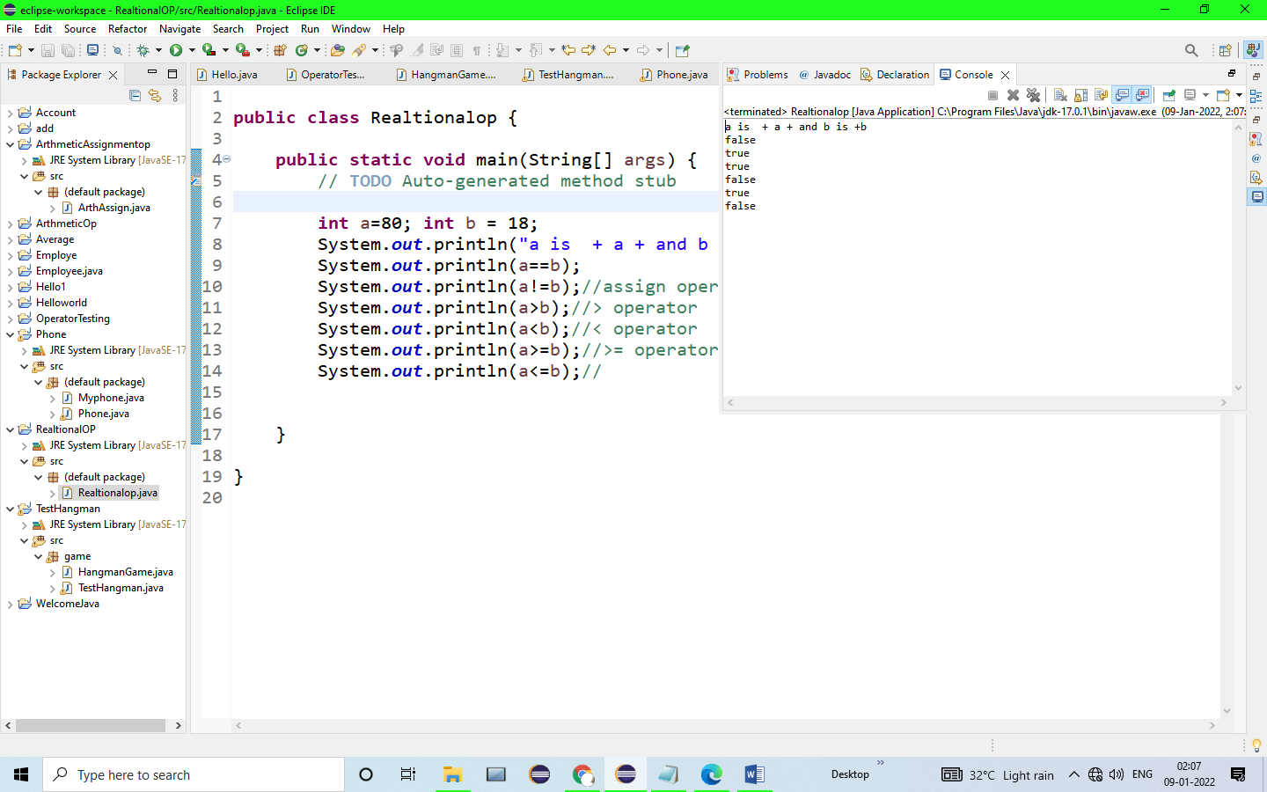

OUTPUT:

a is + a + and b is +b

false

true

true

false

true

false

5.Write your own program using logical operators.

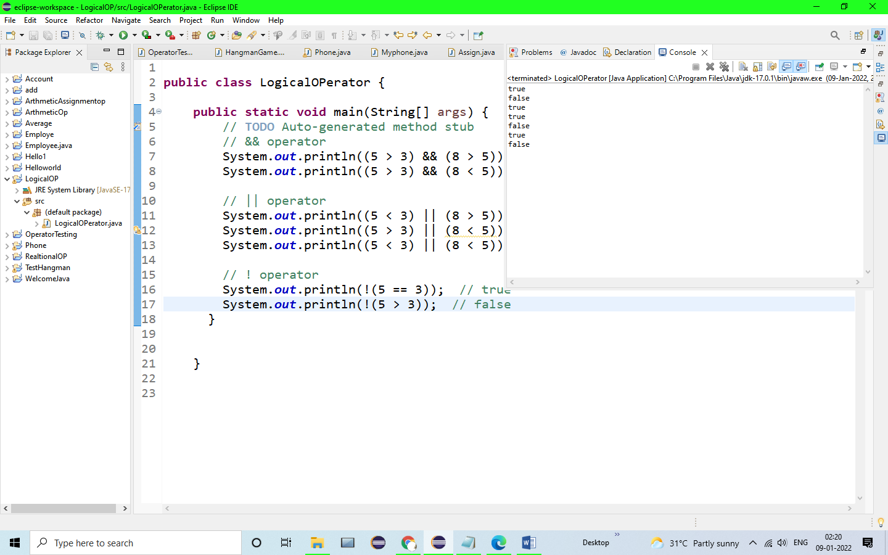

OUTPUT:

true

false

true

true

false

true

false

6.Write your own program to show the use of assignment operator.

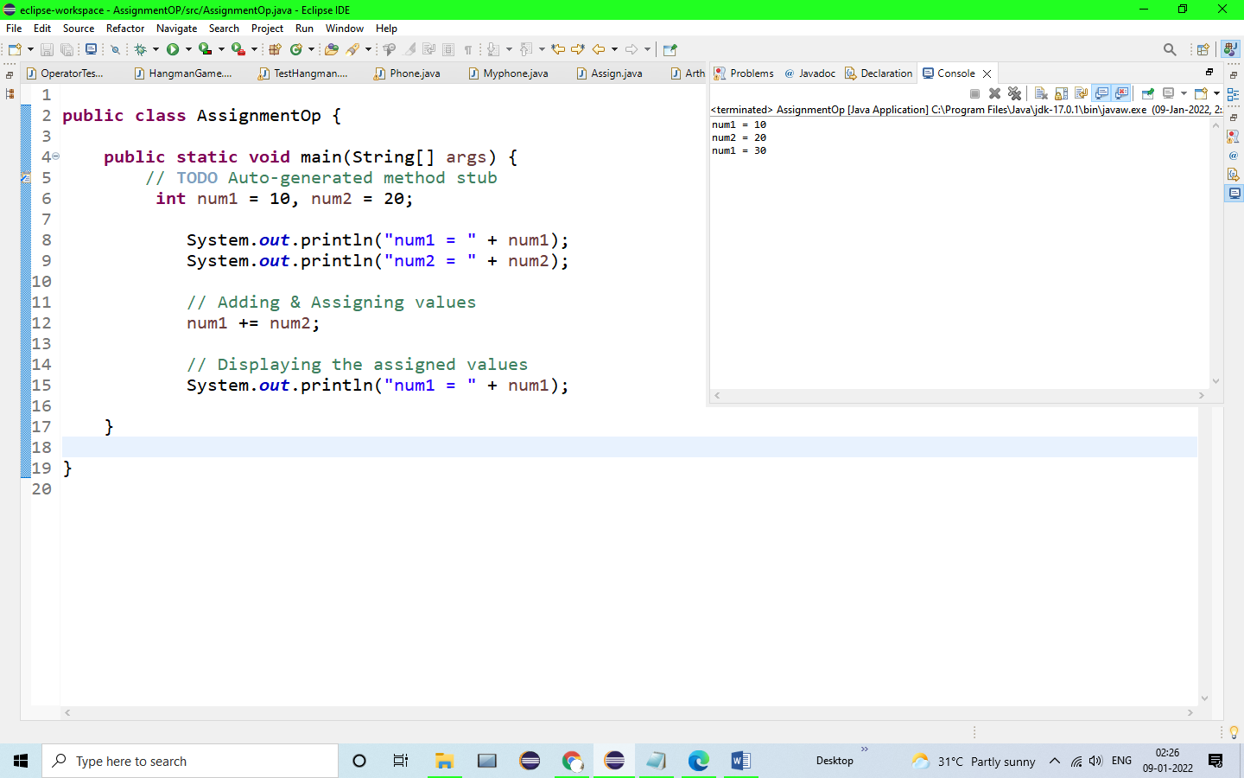

OUTPUT:

num1 = 10

num2 = 20

num1 = 30

7.Write a program to check number is even or odd.

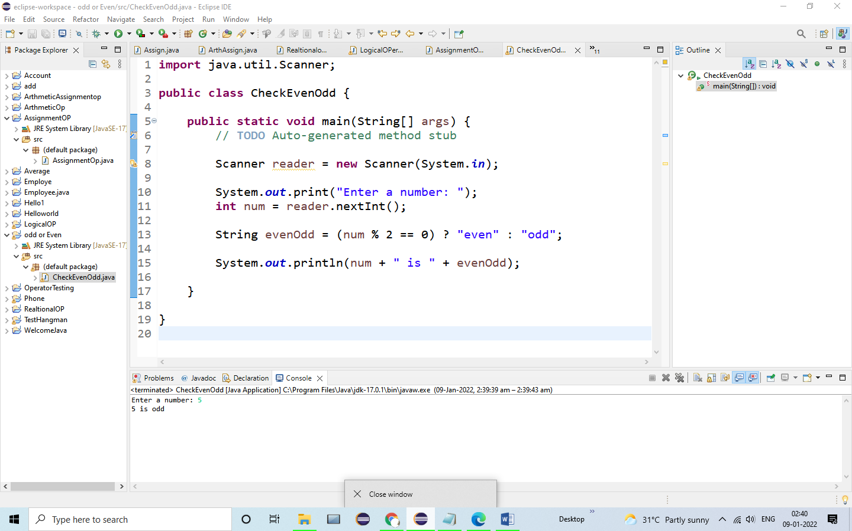

OUTPUT:

Enter a number: 5

5 is odd

8.write a program to check whether both numbers are same or not.